Project Design Phase-II
Technology Stack (Architecture & Stack)

Date | 31 January 3035
Team ID | LTVIP2026TMIDS88461
Project Name | DocSpot — Seamless Appointment Booking
Maximum Marks | 4 Marks

Technical Architecture:
The Deliverable shall include the architectural diagram as below and the information as per the table1 & table 2
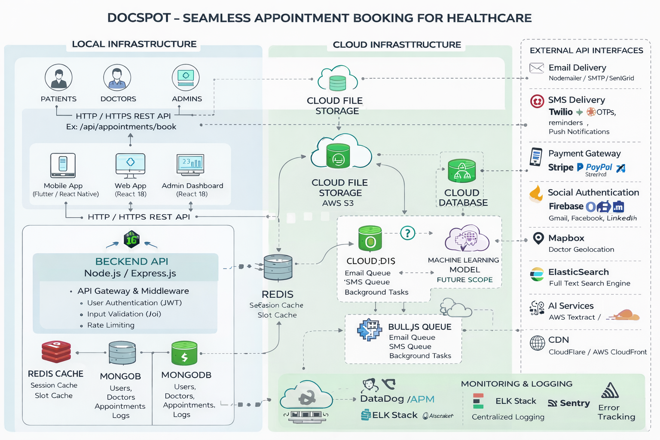

Table-1 : Components & Technologies:

S.No | Component | Description | Technology Used
1 | User Interface – Web | Web interface for patients, doctors, and admin dashboard. | React 18, HTML5, CSS3, Bootstrap / Ant Design, Axios
2 | User Interface – Mobile | Mobile app for appointment booking and management. | React Native / Flutter
3 | API Gateway & Middleware | Handles routing, authentication, validation, and request filtering. | Express.js, CORS, Helmet.js, Morgan
4 | User Authentication Service | Manages registration, login, password reset, JWT tokens. | Node.js, JWT, bcryptjs
5 | Doctor Management Service | Handles doctor registration, approval workflow, availability management. | Node.js, Mongoose
6 | Appointment Management Service | Core booking logic, slot validation, rescheduling, cancellation. | Node.js, Express.js
7 | Notification Service | Sends email confirmations, reminders, and alerts. | Bull Queue, Redis, Nodemailer, SendGrid
8 | SMS & Push Notification Service | Sends OTP and reminders via SMS and mobile push. | Twilio, Firebase Cloud Messaging
9 | Document Management | Secure upload and storage of prescriptions and reports. | Multer, Local Storage / AWS S3
10 | Database | Stores users, doctors, appointments, audit logs. | MongoDB (Atlas / Local), Mongoose
11 | Cache Layer | Improves performance and stores temporary session data. | Redis
12 | Message Queue | Handles asynchronous tasks like email & SMS processing. | Bull.js
13 | File Storage | Stores uploaded medical documents securely. | Local FS / AWS S3
14 | External APIs | Social login and third-party integrations. | Google OAuth, Facebook API, LinkedIn API
15 | Infrastructure | Deployment environment for hosting backend and frontend. | AWS EC2 / Local Linux Server / Docker / Nginx
Table-2: Application Characteristics:
S.No | Characteristics | Description | Implementation
1 | Open-Source Frameworks | Uses modern open-source technologies. | React, Express.js, MongoDB, Redis
2 | Security | Protects user data and prevents unauthorized access. | HTTPS, JWT Authentication, bcrypt hashing, RBAC
3 | Scalability | Supports increasing users and appointment load. | Auto-scaling (Cloud), Redis caching, Load balancer
4 | Availability | Ensures system uptime and reliability. | Cloud deployment, Multi-instance setup
5 | Performance | Fast API responses and optimized queries. | Indexing, Caching, CDN
6 | Backup & Recovery | Prevents data loss with regular backups. | MongoDB automated backups
7 | Monitoring & Logging | Tracks system health and errors. | Winston logs, CloudWatch, ELK Stack
8 | Compliance | Ensures healthcare data privacy compliance. | GDPR-ready design, Encrypted storage
9 | Deployment | Supports both local and cloud environments. | Docker, AWS, Nginx

